**2024 Overseas Student Recruitment of Bambu Lab**

**About Bambu Lab**

Bambu Lab is a consumer tech company focusing on desktop 3D printers. Starting with the X1 series, Bambu Lab builds state-of-the-art 3D printers that break the barriers between the digital and physical worlds, bringing creativity to a whole new level. Right now we have five sites located at Shenzhen and Shanghai in China, Japan, Germany, and Austin, Texas of U.S.

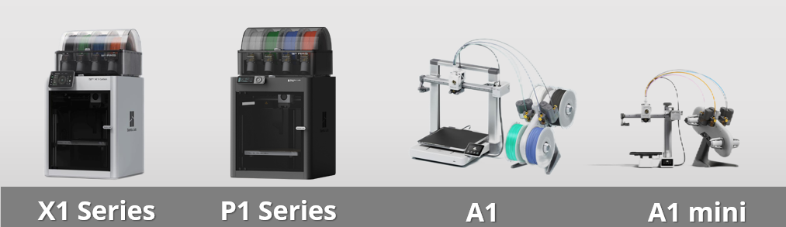

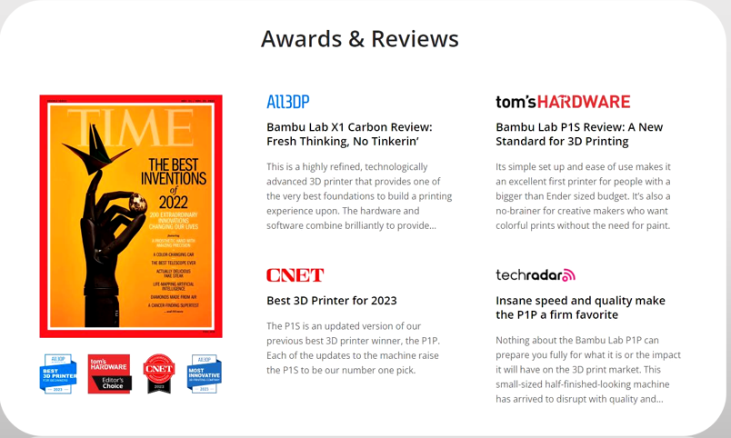

**Our Team**

Our story started with the gathering of a team of 3D printing fans, who are also expert engineers in robotics, artificial intelligence, materials science, and internet industries. Our team is experienced in building high-tech products that bring positive impacts to the world. From the start, we have been dedicated to making cutting-edge technology affordable with advanced know-how and high production quality. We see ourselves as part of the ecosystem and are delighted to learn from and share knowledge with the 3D printing community. Our team's passion lies also in the commitment to creating the next generation of eco-friendly 3D printers - pushing the industry toward a future with a much lower carbon-footprint.

**Job Offers**

**Internship Position**

Hiring Target: University students graduating in 2025 or 2026

**Overseas Social Media Operations Intern**

**Job Description:**

1. Participate in the operation of Bambu's overseas social media, including but not limited to content planning and production.
2. Participate in communication with KOLs and communities, liaising with foreign schools and influencers for collaboration.
3. Assist with basic data collection and analysis, coordinating with upstream and downstream teams to meet various communication needs.

**Job Requirements:**

1. Have a good understanding of the internet and enjoy surfing online, familiar with basic overseas social media platforms.
2. Possess a good understanding of Western culture, with a strong desire to share and explore.
3. Possess excellent English reading and writing skills, able to write social media copy under guidance.
4. Bonus: Proficient in photography, basic video editing skills, and able to independently produce simple marketing materials.
5. Internship duration: 3 months or more.

**Full-time Positions**

Hiring Target: Candidates who have graduated and possess relevant work experience

**PR**

**Job Description:**

1. Develop PR marketing strategies, connect with the media and achieve exposure to key product launch milestones.
2. Writing and producing presentations, articles, press releases and social media posts.
3. Communicate with press and media representatives.
4. Dealing with enquiries from the public, the press and related organisations.
5. Organising and attending promotional events such as press conferences, open days, exhibitions, tours and visits.
6. Speaking publicly at interviews, press conferences and presentations.
7. Providing clients/colleagues with information about new promotional opportunities and current PR campaigns’ progress.
8. Analysing media coverage.
9. Commissioning or undertaking relevant market research and data analysis on PR side.

**Job Requirements:**

**Skills and qualifications**

1. Superb written and verbal communication skills
2. Experience networking and building relationships with the press
3. Great at public speaking and presenting
4. Aptitude for strategic problem-solving
5. Proficient in all social media platforms, such as Instagram, Twitter, Facebook, and LinkedIn
6. Ability to diffuse tense situations and stay calm in a crisis

**Preferred qualifications**

1. Previous PR or media management experience
2. Knowledge of 3D printing industry
3. Strong writing and editing skills
4. Native English speakers preferred

**Social Media and Community Specialist**

**Job Description:**

1. Developing social media content plans that are consistent with the company’s brand identity.
2. Creating consistent, meaningful content on all social media platforms, including writing and editing social media posts, improving customer engagement, and promoting social media campaigns.
3. Managing a high volume of daily social media posts.
4. Communicating with social media followers, including responding to queries in a timely manner.
5. Using analytical tools to monitor and evaluate the company’s social media presence and performance.
6. Preparing monthly reports on social media marketing efforts.
7. Suggesting recommendations to adjust the social media marketing strategy for optimal results.
8. Staying up to date on best practices and emerging trends in social media.
9. Performing other duties when needed.

**Job Requirements:**

1. Bachelor’s degree or above in journalism, communications, marketing, or a related field.
2. Experience with social media, and community patform such as reddit and discord, including planning and managing content in a corporate or agency setting.
3. Excellent written and verbal communication skills and must have a thorough understanding of social media management and strategy.
4. Experience using various analytics software.
5. Multi-tasking and time-management skills, with the ability to prioritize tasks.

**Copy Writer**

**Job Description:**

1. Research the language style that fits the company's products and understand the expressions commonly used in the related industry.
2. Write original copy and edit content for a range of marketing and communications materials.
3. Create copy for product pages and e-commerce sites, with the ability to optimize and enhance the content.
4. Collaborate with a team and creative staff, from concept development to delivery of final product
5. Revise copy based on internal and outside feedback.

**Job Requirements:**

**Required skills and qualifications**

1. Experience with electronics tech companies or tech product enthusiasts preferred.
2. Experience of professional copywriting experience, with solid portfolio of work.
3. Exceptional writing and research skills.
4. Ability to work independently or with a team to meet deadlines.
5. Excellent organizational skills and multitasking ability.
6. Ideally based in Shenzhen, but open to remote work as well.

**Preferred skills and qualifications**

1. Bachelor’s degree (or equivalent) in journalism, English, communications, or related discipline.
2. Proofreading experience and familiarity with standard style guides.
3. Experience with content management systems.
4. Keen eye for detail and appreciation of great design.
5. Has own style and insights when it comes to copywriting.

**Location**

Shenzhen / Remote

**Benefits**

* Competitive compensation and comfortable workspace
* Free breakfast, snacks, team buildings and sports activities
* Full-time opportunities for outstanding interns
* 3D printing discounts and DIY model making

**How to Apply**

**Online Apply**

* Campus Recruitment Website: <https://bambulab.jobs.feishu.cn/campus>
* Email: [zhaopin@bambulab.com](mailto:zhaopin@bambulab.com)
* Official Website: [www.bambulab.com](http://www.bambulab.com/)

**Contact HR**

If you‘re interested in Bambu Lab‘s job，plesse feel free to contact Karen through Email as follows，

Email: huan.li@bambulab.com